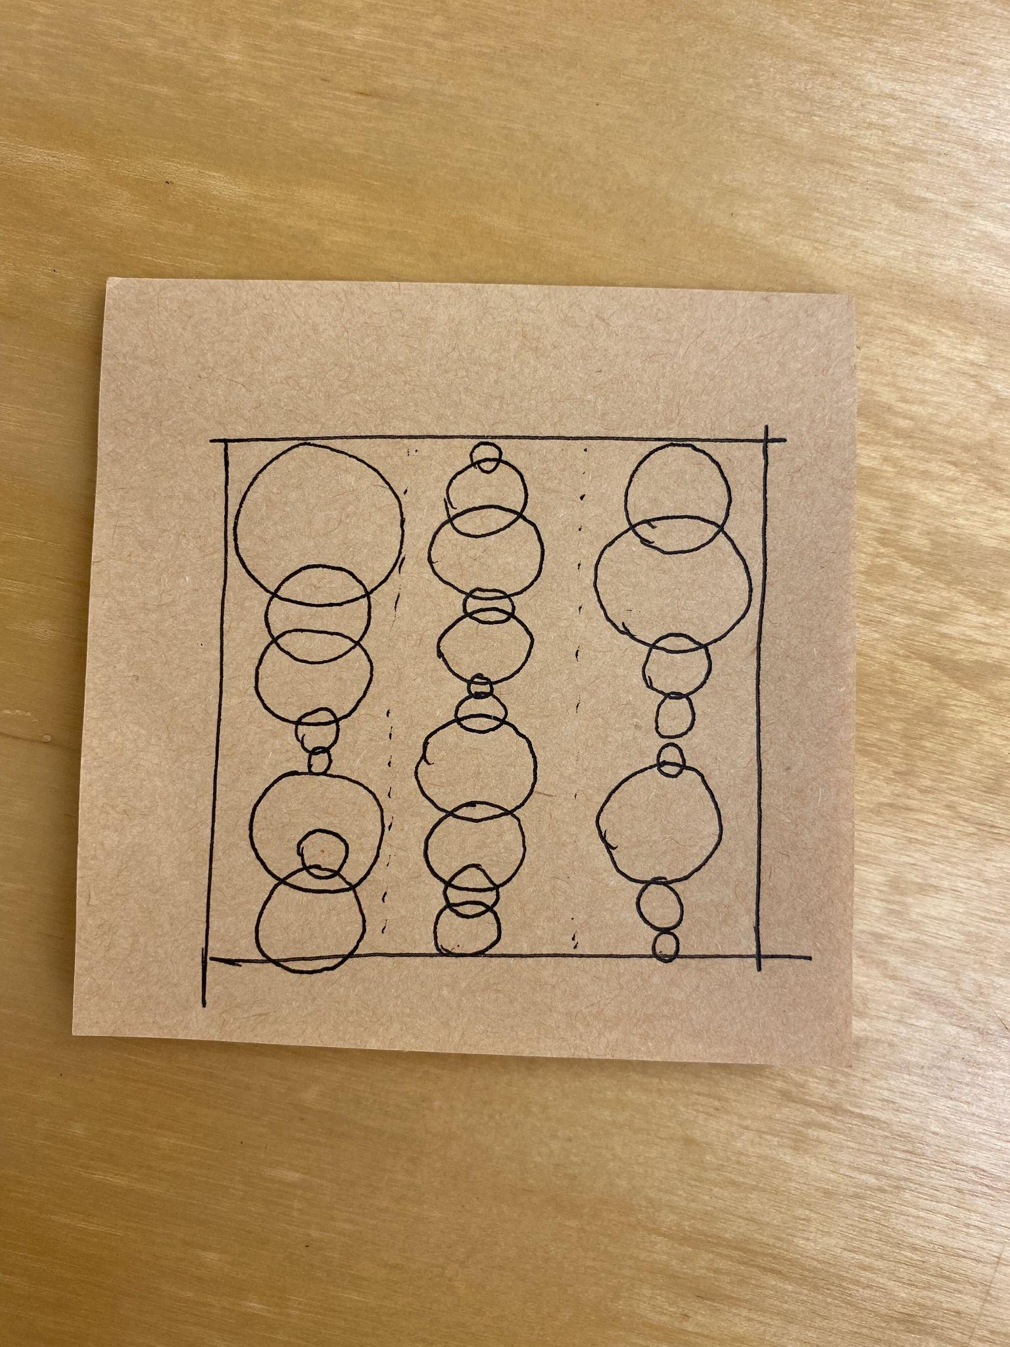Sketch of the pattern

Task: create three or more columns of circles that each column of circles has the same x-axis center point. Use the random library on size and color to create the art.

Import turtle, random libraries

Set the turtle color mode to accept RGB color

turtle.colormode(255)

Set the panel background color

panel=turtle.Screen()bg.color(“color name or code”)

Set the drawing speed to the fastest speed

turtle.speed(10)

Pick up the pen and get ready to draw

First turtle: circle

Define the angle increment between shapes in the pattern

Define the number of iterations to make a complete circle

Set the maximum and minimum radius of circle

Set the fixed x-axis

Let turtle go to the first ⅓ column of the screen

turtle.goto(x,y)

Set the x-axis for 3 columns

Set the y-axis range for 3 columns

Use a for loop to draw pattern in these 3 columns

For i in range(y-axis):

turtle.goto(x,i)

Use a for loop to create the pattern

For i in range(number of circles):

turtle.down()to put down the pen

Set the circle shape and put the turtle radius

random.(circle radius maxi and min)

Move turtle forward in y-axis using the random radius of the inner circle

Use a for loop to fill in different color to the circle

turtle.bengin_fill()

For i in range(color list):

turtle.color(i)

turtle.end_fill()